DLD lab report 6
student number: 16329561

Negative edge triggered D flip-flop:

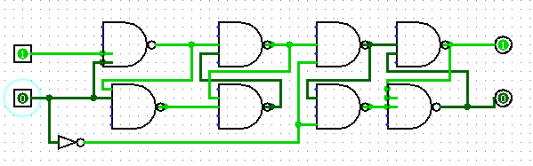

This flip-flop works as follow. Only when the clock switch from a logic state 1 to a logic state 0 can the state of the outputs change. From that, if data is 1, then Q will stay 1 or change to 1. And if data is 0 then Q will become 0 or stay 0.

J-K flip-flop PS/NS table:

J | K | Q(next) | Q’(next)
0 | 0 | Q | Q’
0 | 1 | 0 | 1
1 | 0 | 1 | 0
1 | 1 | Q’ | Q

A J-K flip-flop can be rising edge or falling edge, but when both inputs are 1, they act as a toggle flip-flop.

J-K flip-flop ASM:

We just read from the PS/NS table and we can draw an ASM with it. Diamonds represents evaluation and rectangle the state of our output.
